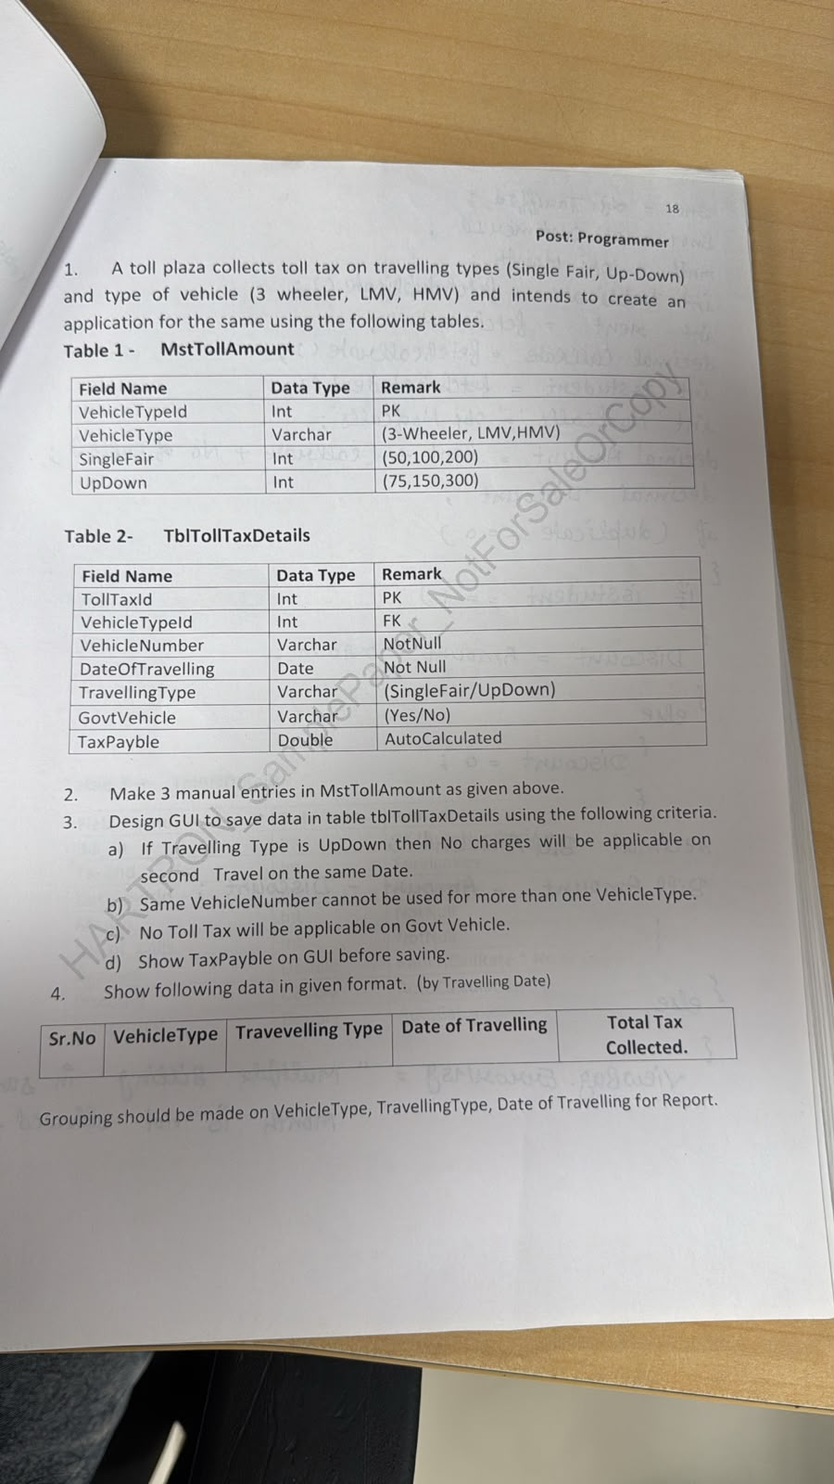

Model
using System;
using System.ComponentModel.DataAnnotations;

namespace TollPlaza.Models
{
public class TollTaxModel
{
public int TollTaxId { get; set; }

[Required]
[Display(Name = "Vehicle Type")]
public int VehicleTypeId { get; set; }

[Required]
[Display(Name = "Vehicle Number")]
public string VehicleNumber { get; set; }

[Required]
[Display(Name = "Date Of Travelling")]
[DataType(DataType.Date)]
public DateTime DateOfTravelling { get; set; }

[Required]
[Display(Name = "Travelling Type")]
public string TravellingType { get; set; }

[Required]
[Display(Name = "Govt Vehicle")]
public string GovtVehicle { get; set; }

[Display(Name = "Tax Payble")]
public double TaxPayble { get; set; }
}
}

Controller

using TollPlaza.Models;
using System;
using System.Configuration;
using System.Data;
using System.Data.SqlClient;
using System.Linq;
using System.Web.Mvc;

namespace TollPlaza.Controllers
{
public class HomeController : Controller
{
public ActionResult Index()
{
var vehicleType = getvehicletype();
ViewBag.vehicletype = new SelectList(vehicleType.AsDataView(), "VehicleTypeId", "VehicleType");
return View();
}

[HttpPost]
public ActionResult Index(TollTaxModel obj)
{
var vehicleType = getvehicletype();
ViewBag.vehicletype = new SelectList(vehicleType.AsDataView(), "VehicleTypeId", "VehicleType");

// Rule b: same VehicleNumber cannot be used for more than one VehicleType
int existingVehicleTypeId = getexistingvehicletype(obj.VehicleNumber);
if (existingVehicleTypeId != 0 && existingVehicleTypeId != obj.VehicleTypeId)
{
ViewBag.Message = "This Vehicle Number is already registered under a different Vehicle Type";
return View(obj);
}

double tax = calculatetax(obj.VehicleTypeId, obj.TravellingType, obj.GovtVehicle, obj.VehicleNumber, obj.DateOfTravelling);
obj.TaxPayble = tax;

string cnn = ConfigurationManager.ConnectionStrings["cn"].ConnectionString;
SqlConnection con = new SqlConnection(cnn);
string query = "insert into TblTollTaxDetails values (@VehicleTypeId, @VehicleNumber, @DateOfTravelling, @TravellingType, @GovtVehicle, @TaxPayble)";
SqlCommand cmd = new SqlCommand(query, con);
cmd.Parameters.Add("@VehicleTypeId", SqlDbType.Int).Value = obj.VehicleTypeId;
cmd.Parameters.Add("@VehicleNumber", SqlDbType.VarChar).Value = obj.VehicleNumber;
cmd.Parameters.Add("@DateOfTravelling", SqlDbType.Date).Value = obj.DateOfTravelling;
cmd.Parameters.Add("@TravellingType", SqlDbType.VarChar).Value = obj.TravellingType;
cmd.Parameters.Add("@GovtVehicle", SqlDbType.VarChar).Value = obj.GovtVehicle;
cmd.Parameters.Add("@TaxPayble", SqlDbType.Float).Value = tax;
con.Open();
cmd.ExecuteNonQuery();
con.Close();

ViewBag.Message = "Record Successfully Saved. Tax Payble was Rs. " + tax;

return View(new TollTaxModel());
}

public DataTable getvehicletype()
{
string cnn = ConfigurationManager.ConnectionStrings["cn"].ConnectionString;
using (SqlConnection con = new SqlConnection(cnn))
{
SqlDataAdapter adb = new SqlDataAdapter("Select * from MstTollAmount", con);
DataTable dt = new DataTable();
adb.Fill(dt);
return dt;
}
}

// Rule c: Govt Vehicle -> no tax
// Rule a: UpDown, second travel same date by same vehicle -> no tax
public double calculatetax(int vehicleTypeId, string travellingType, string govtVehicle, string vehicleNumber, DateTime dateOfTravelling)
{
if (govtVehicle == "Yes")
{
return 0;
}

if (travellingType == "UpDown")
{
int trips = getupdowntripstoday(vehicleNumber, dateOfTravelling);
if (trips > 0)
{
return 0;
}
}

return getfair(vehicleTypeId, travellingType);
}

public double getfair(int vehicleTypeId, string travellingType)
{
string cnn = ConfigurationManager.ConnectionStrings["cn"].ConnectionString;
SqlConnection con = new SqlConnection(cnn);
string column = travellingType == "UpDown" ? "UpDown" : "SingleFair";
string query = "select " + column + " from MstTollAmount where VehicleTypeId = @VehicleTypeId";
SqlCommand cmd = new SqlCommand(query, con);
cmd.Parameters.Add("@VehicleTypeId", SqlDbType.Int).Value = vehicleTypeId;
con.Open();
double fair = Convert.ToDouble(cmd.ExecuteScalar());
con.Close();
return fair;
}

public int getupdowntripstoday(string vehicleNumber, DateTime dateOfTravelling)
{
string cnn = ConfigurationManager.ConnectionStrings["cn"].ConnectionString;
SqlConnection con = new SqlConnection(cnn);
string query = "select count(*) from TblTollTaxDetails where VehicleNumber = @VehicleNumber and DateOfTravelling = @DateOfTravelling and TravellingType = 'UpDown'";
SqlCommand cmd = new SqlCommand(query, con);
cmd.Parameters.Add("@VehicleNumber", SqlDbType.VarChar).Value = vehicleNumber;
cmd.Parameters.Add("@DateOfTravelling", SqlDbType.Date).Value = dateOfTravelling;
con.Open();
int trips = Convert.ToInt32(cmd.ExecuteScalar());
con.Close();
return trips;
}

public int getexistingvehicletype(string vehicleNumber)
{
int vehicleTypeId = 0;
string cnn = ConfigurationManager.ConnectionStrings["cn"].ConnectionString;
SqlConnection con = new SqlConnection(cnn);
string query = "select top 1 VehicleTypeId from TblTollTaxDetails where VehicleNumber = @VehicleNumber";
SqlCommand cmd = new SqlCommand(query, con);
cmd.Parameters.Add("@VehicleNumber", SqlDbType.VarChar).Value = vehicleNumber;
con.Open();
object result = cmd.ExecuteScalar();
con.Close();
if (result != null && result != DBNull.Value)
{
vehicleTypeId = Convert.ToInt32(result);
}
return vehicleTypeId;
}

public ActionResult Report1()
{
string cnn = ConfigurationManager.ConnectionStrings["cn"].ConnectionString;
string query = @"select ROW_NUMBER() over (order by m.VehicleType) as [Sr. No.], m.VehicleType as [Vehicle Type], t.TravellingType as [Travelling Type], t.DateOfTravelling as [Date of Travelling], sum(t.TaxPayble) as [Total Tax Collected] from TblTollTaxDetails t inner join MstTollAmount m on m.VehicleTypeId = t.VehicleTypeId group by m.VehicleType, t.TravellingType, t.DateOfTravelling";
SqlDataAdapter adb = new SqlDataAdapter(query, cnn);
DataTable dt = new DataTable();

adb.Fill(dt);
ViewBag.ResultTable = dt;

return View();

}

public ActionResult About()
{
ViewBag.Message = "Your application description page.";

return View();
}

public ActionResult Contact()
{
ViewBag.Message = "Your contact page.";

return View();
}
}
}
Index
@model TollPlaza.Models.TollTaxModel
@{
ViewBag.Title = "Index";
}
<h2>Toll Tax Entry</h2>
@using (Html.BeginForm())
{
@Html.AntiForgeryToken()
<div class="form-horizontal">
<h4>TollTaxDetails</h4>
<hr />
@Html.ValidationSummary(true, "", new { @class = "text-danger" })
<div class="form-group">
@Html.LabelFor(model => model.VehicleTypeId, htmlAttributes: new { @class = "control-label col-md-2" })
<div class="col-md-10">
@Html.DropDownListFor(model => model.VehicleTypeId, (SelectList)ViewBag.vehicletype, "---Select Vehicle Type---", new { @class = "form-control" })
@Html.ValidationMessageFor(model => model.VehicleTypeId, "", new { @class = "text-danger" })
</div>
</div>
<div class="form-group">
@Html.LabelFor(model => model.VehicleNumber, htmlAttributes: new { @class = "control-label col-md-2" })
<div class="col-md-10">
@Html.EditorFor(model => model.VehicleNumber, new { htmlAttributes = new { @class = "form-control" } })
@Html.ValidationMessageFor(model => model.VehicleNumber, "", new { @class = "text-danger" })
</div>
</div>
<div class="form-group">
@Html.LabelFor(model => model.DateOfTravelling, htmlAttributes: new { @class = "control-label col-md-2" })
<div class="col-md-10">
@Html.EditorFor(model => model.DateOfTravelling, new { htmlAttributes = new { @class = "form-control", type = "Date" } })
@Html.ValidationMessageFor(model => model.DateOfTravelling, "", new { @class = "text-danger" })
</div>
</div>
<div class="form-group">
@Html.LabelFor(model => model.TravellingType, htmlAttributes: new { @class = "control-label col-md-2" })
<div class="col-md-10">
@Html.DropDownListFor(model => model.TravellingType, new SelectList(new[] { "SingleFair", "UpDown" }), "---Select Travelling Type---", new { @class = "form-control" })
@Html.ValidationMessageFor(model => model.TravellingType, "", new { @class = "text-danger" })
</div>
</div>
<div class="form-group">
@Html.LabelFor(model => model.GovtVehicle, htmlAttributes: new { @class = "control-label col-md-2" })
<div class="col-md-10">
@Html.DropDownListFor(model => model.GovtVehicle, new SelectList(new[] { "Yes", "No" }), "---Select---", new { @class = "form-control" })
@Html.ValidationMessageFor(model => model.GovtVehicle, "", new { @class = "text-danger" })
</div>
</div>
<div class="form-group">
@Html.LabelFor(model => model.TaxPayble, htmlAttributes: new { @class = "control-label col-md-2" })
<div class="col-md-10">
@Html.EditorFor(model => model.TaxPayble, new { htmlAttributes = new { @class = "form-control", @readonly = "readonly" } })
</div>
</div>
<div class="form-group">
<div class="col-md-offset-2 col-md-10">
<input type="submit" value="Save Record" class="btn btn-success" />
</div>
</div>
</div>
}
@ViewBag.Message
<div>
@Html.ActionLink("Back to List", "Index")
| @Html.ActionLink("View Reports", "Reports")
</div>

Report1 Index

@{
var dt = ViewBag.ResultTable as System.Data.DataTable;
}

<table class="table table-bordered table-striped table-hover text-center">
<tr>
<th>Sr. No.</th>
<th>Vehicle Type</th>
<th>Travelling Type</th>
<th>Date of Travelling</th>
<th>Total Tax Collected</th>

</tr>

@if (dt != null)
{
foreach (System.Data.DataRow row in dt.Rows)
{
<tr>
<td>@row["Sr. No."]</td>
<td>@row["Vehicle Type"]</td>
<td>@row["Travelling Type"]</td>
<td>@row["Date of Travelling"]</td>
<td>@row["Total Tax Collected"]</td>

</tr>

}
}

</table>

